DATA SCIENCE WITH PYTHON
Unsupervised Learning and Clustering Analysis
Segmenting 52 jurisdiction mortality profiles with K-Means
━━━━━━━━━━━━━━━━━━━━━━━━━━━━━━━━━━━━━━━━━━━━━━━
WEEK | 3
DATE | 12 August 2026
DATASET | Provisional COVID-19 Deaths by Sex and Age

Student name | Mandal Sahil Naushad
Institution | YuvaIntern
Public-use aggregate mortality data • Reproducible Python workflow

Report map
The document follows the required submission structure. Major sections are separated visually and use Word heading styles for navigation.
- 1. Title Page
- 2. Introduction
- 3. Dataset Overview
- 4. Methodology
- 5. Python Code Sections
- 6. Results and Findings
- 7. Visualizations (described in text)
- 8. Challenges and How They Were Handled
- 9. Discussion
- 10. Conclusion
- 11. References

2. Introduction
This report groups U.S. states, the District of Columbia, and Puerto Rico according to how COVID-19 mortality is distributed across all deaths, pneumonia overlap, influenza, older age, sex, and pandemic year. The aim is descriptive segmentation: identify jurisdictions with similar profiles even when their raw population and death counts differ.
The cleaned CDC dataset is suitable because it supplies the same cumulative and yearly measures for every jurisdiction. Week 2 showed that raw counts are heavily affected by jurisdiction size, so the clustering question is framed around seven percentages. The practical question is whether a small number of recurring mortality profiles can guide targeted comparison, monitoring, and hypothesis generation.
Interpretation boundary. The selected four-cluster solution has a silhouette score of 0.222, which is modest. The clusters are useful descriptive neighborhoods, not natural laws or causal categories.

3. Dataset Overview
The source file contains 137,700 rows and 16 raw columns; analysis starts from the 25-column Week 1 clean artifact. I excluded the national total and New York City. The United States is an aggregate, while New York City overlaps New York; keeping either in the jurisdiction matrix would distort distance and independence. The final modeling unit is 52 jurisdictions.
Feature | Definition | Why included
COVID % of all deaths | 100 × COVID-19 / total deaths | Overall COVID composition without raw size.
Pneumonia % of all deaths | 100 × pneumonia / total deaths | Respiratory mortality context.
COVID with pneumonia % | 100 × pneumonia+COVID / COVID | Clinical/coding overlap profile.
Influenza % of all deaths | 100 × influenza / total deaths | Separates non-COVID respiratory burden.
Age 65+ COVID % | 65–74 + 75–84 + 85+ COVID / all-age COVID | Age concentration.
Male COVID % | Male / (Male + Female) COVID | Sex composition.
2021 % of 2020–22 COVID | 2021 / sum of 2020, 2021, 2022 | Wave timing without partial 2023.
Table 1. Seven scale-free features used for clustering.
The cumulative fields used for features are observed for all 52 units, so no suppressed model feature required imputation. Raw features use different percentage ranges and variances; StandardScaler centers each at zero and scales to unit variance before Euclidean distance is calculated.

4. Methodology
The workflow follows the required order: select an appropriate unit, preprocess to improve clustering, apply and tune K-Means, visualize the solution, and translate cluster profiles into practical meaning.

Step 1 — Define an independent analytical unit
Each row of the feature matrix represents one non-overlapping jurisdiction. Excluding the national total prevents a single aggregate from sitting far from every state, and excluding New York City prevents one region from being represented twice.

Step 2 — Engineer interpretable percentage features
I avoided raw counts because they would mostly separate California and Texas from smaller states. Each feature answers a distinct composition or timing question. The age numerator uses exactly three mutually exclusive older bands, and the year-timing feature stops at 2022 because 2023 is incomplete.

Step 3 — Check completeness, correlation, and scale
All 364 feature cells are observed. The seven variables are standardized because a one-percentage-point difference has different meaning across low-variance influenza share and higher-variance pneumonia overlap. Standardization gives each feature an opportunity to influence distance while retaining its direction.

Step 4 — Compare candidate cluster counts
K-Means was run for k=2 through k=8 with 50 random initializations per candidate and random_state=42. I examined inertia for compactness and silhouette for separation. Silhouette reaches its highest value at k=4 (0.222); k=7 is close at 0.220 but creates more, smaller groups with less stable practical interpretation. Four clusters are therefore selected.

Step 5 — Fit the final model and visualize structure
The final four-cluster K-Means uses 100 starts to reduce sensitivity to poor centroid initialization. PCA projects the standardized seven-dimensional matrix to two dimensions for display; the first two components retain 62.19% of variance. A Ward-linkage dendrogram provides a second view of similarity without changing the K-Means assignments.

Step 6 — Name clusters from centroid profiles
Labels are based on cluster means relative to the full 52-jurisdiction mean, not on geography alone. I report membership and exact centroid values, then give plain-language names. These names summarize observed profiles and should not be used to rank policy performance.

5. Python Code Sections

Code 1 — Imports and clean data load
```python
from pathlib import Path
import matplotlib.pyplot as plt
import numpy as np
import pandas as pd
import seaborn as sns
from scipy.cluster.hierarchy import dendrogram, linkage
from sklearn.cluster import KMeans
from sklearn.decomposition import PCA
from sklearn.metrics import silhouette_score
from sklearn.preprocessing import StandardScaler
df = pd.read_csv("cleaned_covid_deaths.csv",
parse_dates=["data_as_of", "start_date", "end_date"])
jurisdictions = sorted(set(df["state"]) - {"United States", "New York City"})
```
Code explanation and output interpretation
- The code continues from the Week 1 artifact and uses the actual clean field names.
- Removing United States and New York City leaves 52 non-overlapping modeling units: 50 states, DC, and Puerto Rico.
- All subsequent joins use jurisdiction name as the index, making row alignment explicit.

Code 2 — Construct the seven-feature jurisdiction matrix
```python
base = df.query(
"group == 'By Total' and sex == 'All Sexes' and age_group == 'All Ages'"
).loc[lambda x: x["state"].isin(jurisdictions)].set_index("state")
features = pd.DataFrame(index=jurisdictions)
features["covid_pct_all_deaths"] = 100 * base["covid_deaths"] / base["total_deaths"]
features["pneumonia_pct_all_deaths"] = 100 * base["pneumonia_deaths"] / base["total_deaths"]
features["covid_with_pneumonia_pct"] = 100 * base["pneumonia_covid_deaths"] / base["covid_deaths"]
features["influenza_pct_all_deaths"] = 100 * base["influenza_deaths"] / base["total_deaths"]
age65 = df.query(
"group == 'By Total' and sex == 'All Sexes' "
"and age_group in ['65-74 years', '75-84 years', '85 years and over']"
).loc[lambda x: x["state"].isin(jurisdictions)].groupby("state")["covid_deaths"].sum()
features["age_65plus_covid_pct"] = 100 * age65 / base["covid_deaths"]
```
Code explanation and output interpretation
- The first four features are cumulative burden/overlap percentages, and the fifth measures older-age concentration.
- All divisions use like-for-like cumulative records at one sex and age grain.
- Using shares prevents high-population states from dominating solely because their counts are larger.

Code 3 — Add sex and wave-timing composition
```python
sex = df.query(
"group == 'By Total' and age_group == 'All Ages' and sex in ['Female', 'Male']"
).loc[lambda x: x["state"].isin(jurisdictions)]
sex = sex.pivot(index="state", columns="sex", values="covid_deaths")
features["male_covid_pct"] = 100 * sex["Male"] / (sex["Male"] + sex["Female"])
yearly = df.query(
"group == 'By Year' and sex == 'All Sexes' and age_group == 'All Ages' "
"and year in [2020, 2021, 2022]"
).loc[lambda x: x["state"].isin(jurisdictions)]
yearly = yearly.pivot(index="state", columns="year", values="covid_deaths")
features["covid_2021_pct_2020_22"] = 100 * yearly[2021] / yearly.sum(axis=1)
assert features.shape == (52, 7)
assert features.notna().all().all()
```
Code explanation and output interpretation
- The sex feature measures composition rather than the male/female count ratio, keeping it on a bounded percentage scale.
- The wave feature excludes partial 2023 and records how concentrated 2020–22 burden was in 2021.
- The assertions confirm the intended 52 × 7 matrix with no imputed feature cells.

Code 4 — Standardize and select k with silhouette plus inertia
```python
X = StandardScaler().fit_transform(features)
selection = []
for k in range(2, 9):
model = KMeans(n_clusters=k, n_init=50, random_state=42)
labels = model.fit_predict(X)
selection.append({
"k": k,
"inertia": model.inertia_,
"silhouette": silhouette_score(X, labels),
})
selection = pd.DataFrame(selection)
best_k = int(selection.loc[selection["silhouette"].idxmax(), "k"])
print(selection)
print("Selected k:", best_k)
```
Code explanation and output interpretation
- Testing multiple k values avoids choosing the number of groups by appearance alone.
- Inertia falls as k increases by construction; silhouette adds a separation criterion that can peak.
- The maximum silhouette is 0.222 at k=4, compared with 0.220 at k=7, so the simpler four-cluster solution is preferred.

Code 5 — Fit final K-Means, profile clusters, and project with PCA
```python
kmeans = KMeans(n_clusters=4, n_init=100, random_state=42)
features["cluster"] = kmeans.fit_predict(X)
# Stable report labels: order cluster IDs by mean COVID share.
order = features.groupby("cluster")["covid_pct_all_deaths"].mean().sort_values().index
remap = {old: new for new, old in enumerate(order)}
features["cluster"] = features["cluster"].map(remap)
profile = features.groupby("cluster").mean(numeric_only=True)
pca = PCA(n_components=2)
features[["pc1", "pc2"]] = pca.fit_transform(X)
print(profile)
print("PCA variance retained:", pca.explained_variance_ratio_.sum())
```
Code explanation and output interpretation
- Using 100 initializations reduces dependence on a single random centroid start.
- Cluster IDs are arbitrary, so remapping by mean COVID share makes the report order reproducible without changing membership.
- The first two principal components retain 62.19% of standardized feature variance; the projection is informative but not a complete representation.

Code 6 — Create a hierarchical robustness view
```python
Z = linkage(X, method="ward")
plt.figure(figsize=(12, 5))
dendrogram(Z, labels=features.index, leaf_rotation=90, leaf_font_size=7)
plt.ylabel("Ward linkage distance")
plt.title("Hierarchical view of jurisdiction profile similarity")
plt.tight_layout()
plt.show()
```
Code explanation and output interpretation
- Ward linkage merges groups that add the least within-cluster variance, providing a non-K-Means view of the same standardized matrix.
- The dendrogram does not assign the final labels; it is used to inspect whether similar neighborhoods persist under another method.
- Several branches align with the four-profile interpretation, while close merge heights reinforce that boundaries are not sharp.

6. Results and Findings
Cluster | n | Plain-language profile | Members
0 | 8 | Lower COVID share; male-skewed; 2021-concentrated | Alaska, Colorado, Hawaii, Idaho, Montana, Oregon, Utah, Washington
1 | 13 | Older-age concentration; lower pneumonia overlap; less 2021-concentrated | Connecticut, Iowa, Kansas, Maine, Massachusetts, Minnesota, Nebraska, New Hampshire, North Dakota, Rhode Island, South Dakota, Vermont, Wisconsin
2 | 23 | Broad higher-burden middle profile | Alabama, Arkansas, Delaware, Georgia, Illinois, Indiana, Kentucky, Louisiana, Maryland, Michigan, Mississippi, Missouri, New Jersey, New York, North Carolina, Ohio, Oklahoma, Pennsylvania, South Carolina, Tennessee, Virginia, West Virginia, Wyoming
3 | 8 | High pneumonia/overlap; younger and male-skewed profile | Arizona, California, District of Columbia, Florida, Nevada, New Mexico, Puerto Rico, Texas
Table 2. Final four clusters and jurisdiction membership.
Cluster | COVID % all | Pneumonia % all | COVID with pneumonia % | 65+ COVID % | Male COVID % | 2021 % of 2020–22
0 | 7.125 | 7.680 | 50.409 | 74.662 | 57.669 | 47.838
1 | 8.130 | 8.040 | 39.041 | 82.672 | 53.565 | 35.012
2 | 9.265 | 9.260 | 47.463 | 76.435 | 53.279 | 42.591
3 | 9.355 | 11.534 | 63.144 | 70.803 | 57.434 | 43.162
Table 3. Selected centroid values; influenza share is included in modeling but omitted here for space.
Cluster 0 contains Alaska, several Mountain/Western states, Hawaii, Oregon, and Washington. Its COVID share is lowest at 7.125%, yet 47.838% of 2020–22 COVID deaths occurred in 2021 and male share is high at 57.669%. The practical profile is lower cumulative composition but later/concentrated and male-skewed burden.
Cluster 1 has the oldest profile: 82.672% of COVID deaths are among ages 65+, pneumonia overlap is the lowest at 39.041%, and only 35.012% of 2020–22 deaths fall in 2021. This is an older-age and less-2021-concentrated profile containing many New England and Upper Midwest jurisdictions.
Cluster 2 is the largest group (23). Its COVID and pneumonia shares are both about 9.26%, older-age concentration is 76.435%, and sex composition is less male-skewed than Clusters 0 and 3. It represents a broad higher-burden middle pattern rather than an extreme on one feature.
Cluster 3 combines the highest pneumonia share (11.534%), highest COVID-with-pneumonia overlap (63.144%), lowest 65+ share (70.803%), and high male share (57.434%). Arizona, California, DC, Florida, Nevada, New Mexico, Puerto Rico, and Texas form this younger, male-skewed, respiratory-overlap profile.

7. Visualizations (described in text)
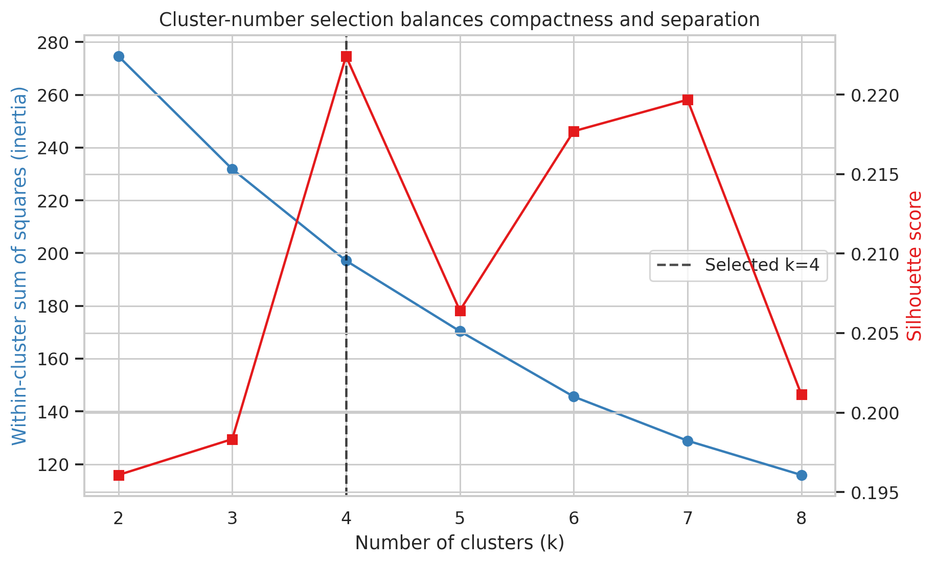
Figure 1. Inertia and silhouette for k=2 through k=8; k=4 has the highest silhouette.
Technical reading: the left axis shows within-cluster sum of squares and the right axis shows silhouette, both by k. Analytical reading: compactness improves continuously, but separation does not. Four groups offer the best measured separation with a much simpler interpretation than the near-tied seven-group alternative.
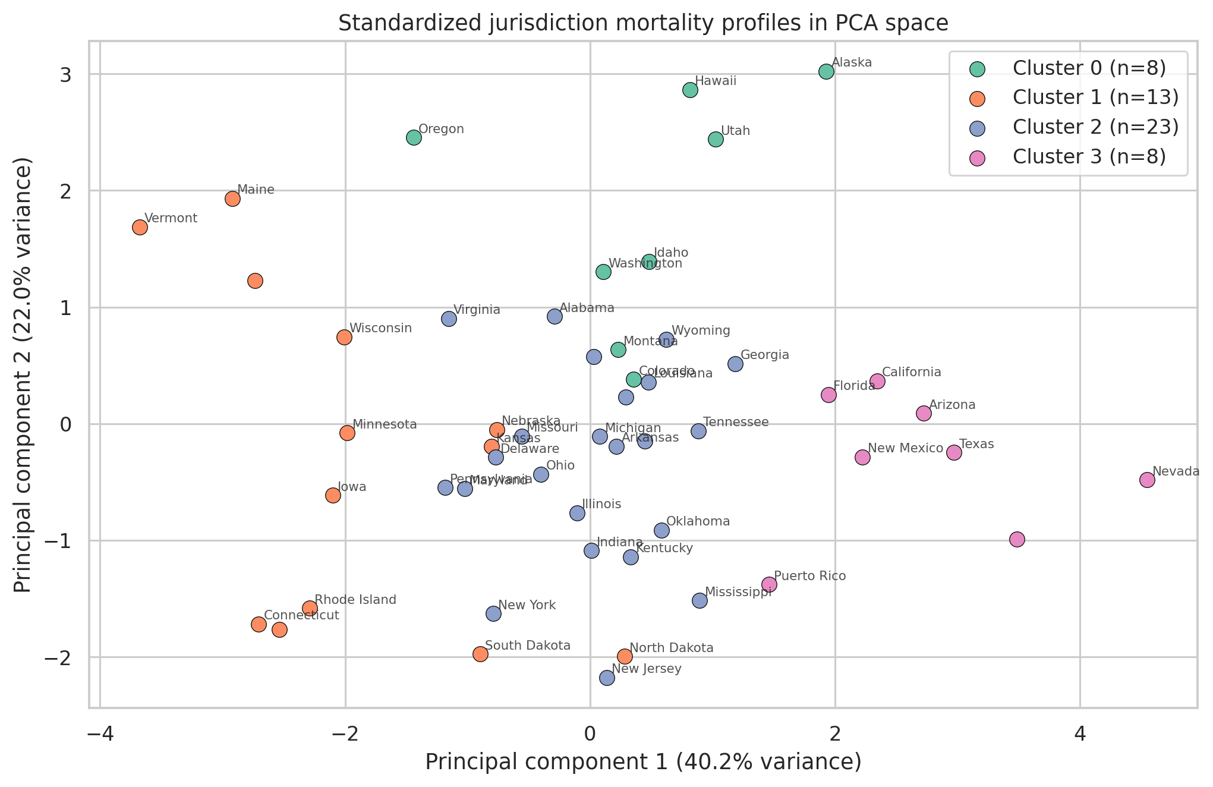
Figure 2. Four K-Means groups in two-dimensional PCA space; the display retains 62.19% of variance.
Technical reading: each point is a standardized jurisdiction profile, color indicates cluster, and axes are the first two principal components. Analytical reading: groups occupy recognizable regions but overlap at boundaries, which agrees with the modest silhouette and argues against treating membership as absolute.
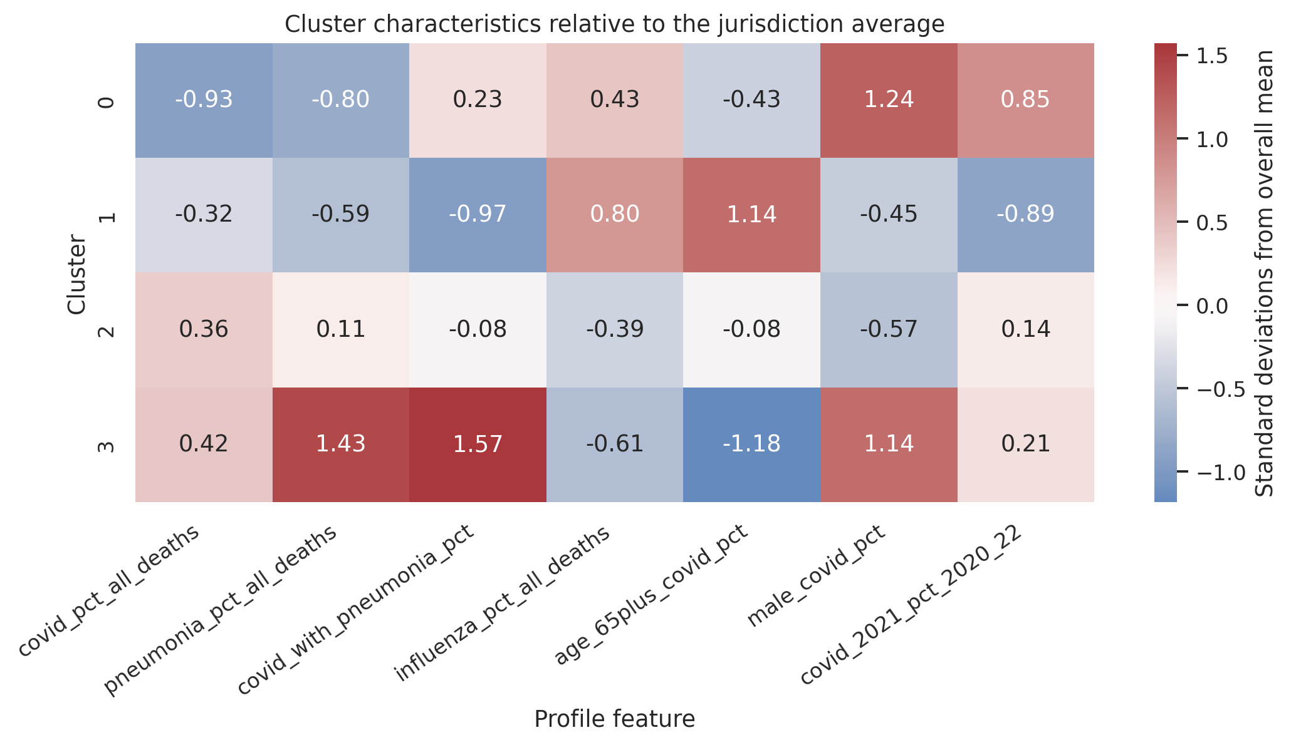
Figure 3. Cluster means expressed as standard deviations above or below the 52-jurisdiction mean.
Technical reading: columns are the seven features, rows are clusters, and color/annotation give standardized centroid deviations. Analytical reading: Cluster 1 is defined most strongly by older-age concentration and low overlap, while Cluster 3 is defined by high pneumonia and overlap plus a younger/male-skewed profile. This reveals the feature combination behind each label.
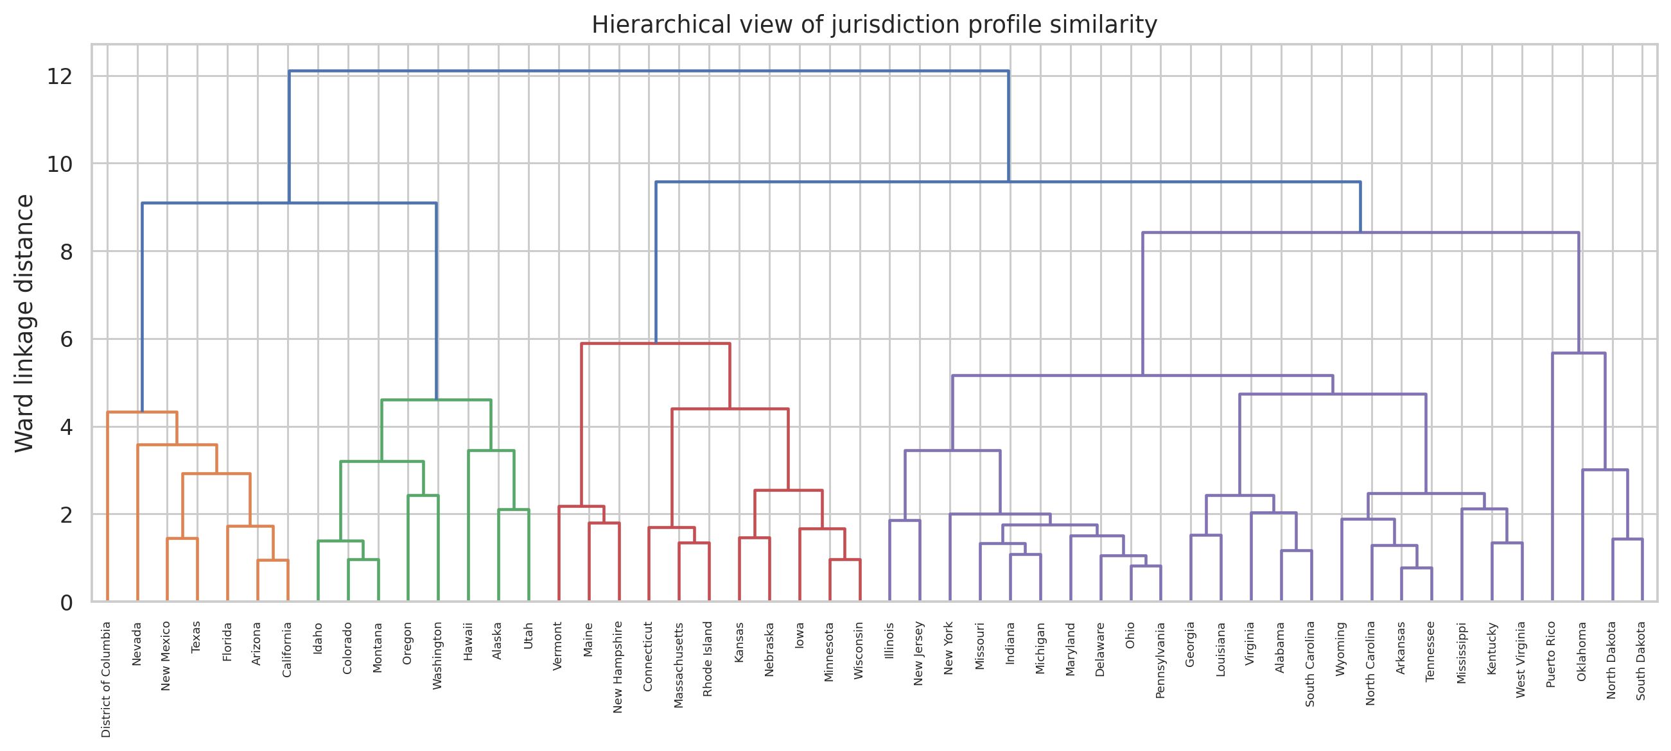
Figure 4. Ward-linkage dendrogram for the same standardized feature matrix.
Technical reading: lower merge height means greater profile similarity. Analytical reading: several tight jurisdiction pairs and subgroups exist, but branch heights rise gradually rather than showing one overwhelming cut. The data support useful segmentation, not a single indisputable taxonomy.

8. Challenges and How They Were Handled
- Raw counts were dominated by population size. I replaced them with seven interpretable percentages before standardization.
- New York City overlaps New York and the national total aggregates every jurisdiction. Both were excluded to preserve independent units.
- The candidate silhouette scores were low and close. I reported them, chose the simplest maximum at k=4, and avoided claiming strong natural separation.
- Cluster numbers changed meaning across random runs. I used n_init=100, random_state=42, and remapped labels by mean COVID share for stable reporting.
- PCA loses 37.81% of variance. It is used only for visualization; K-Means is fit in all seven standardized dimensions.
- 2023 is incomplete. Wave timing uses only 2020–2022 so a partial year cannot reduce the denominator inconsistently.

9. Discussion
The segmentation can support comparison sets. Cluster 1 jurisdictions should prioritize older-adult and long-term-care comparisons because their age concentration is the defining feature. Cluster 3 comparisons should examine pneumonia coding/clinical overlap and working-age male patterns. Cluster 0's 2021 concentration suggests that calendar timing matters when evaluating interventions, while Cluster 2 provides a large reference group for broad burden patterns.
These are research and monitoring implications, not causal diagnoses. Percentage features can still reflect age structure, coding practice, care access, and epidemic timing. A jurisdiction can move clusters if revised provisional counts change a feature. The model contains 52 observations for seven variables, so small cluster differences should be validated with bootstrapping or newer data before operational use.
If preprocessing were skipped, raw totals would mostly create a population-size clustering. If standardization were skipped, high-variance pneumonia overlap could dominate influenza share. If k were chosen only from a visually appealing PCA plot, the decision would ignore the 37.81% of variance outside the display. Each safeguard directly protects interpretability.

10. Conclusion
K-Means on seven standardized mortality-profile percentages produced four interpretable groups of sizes 8, 13, 23, and 8. The selected k has the highest tested silhouette (0.222), and the first two principal components retain 62.19% of variance. Cluster profiles differ most clearly in older-age concentration, male share, pneumonia overlap, overall COVID composition, and concentration in 2021.
The next step is supervised one-month-ahead forecasting. Cluster labels will not be used as targets; instead, chronological lag features and jurisdiction identity will predict monthly COVID-19 counts, with performance compared against a previous-month baseline.

11. References
- Centers for Disease Control and Prevention, National Center for Health Statistics. Provisional COVID-19 Deaths by Sex and Age. Dataset page: https://data.cdc.gov/National-Center-for-Health-Statistics/Provisional-COVID-19-Deaths-by-Sex-and-Age/9bhg-hcku
- CDC data download used for source verification: https://data.cdc.gov/api/views/9bhghcku/rows.csv?accessType=DOWNLOAD
- CDC WONDER provisional mortality access noted by the publisher as the successor source: https://wonder.cdc.gov/mcd-icd10-provisional.html
- McKinney, W. pandas: Python Data Analysis Library. https://pandas.pydata.org/
- Harris, C. R. et al. (2020). Array programming with NumPy. Nature, 585, 357–362. https://numpy.org/
- Waskom, M. L. (2021). seaborn: statistical data visualization. Journal of Open Source Software, 6(60), 3021. https://seaborn.pydata.org/
- Pedregosa, F. et al. (2011). Scikit-learn: Machine Learning in Python. Journal of Machine Learning Research, 12, 2825–2830. https://scikit-learn.org/
- Hunter, J. D. (2007). Matplotlib: A 2D Graphics Environment. Computing in Science & Engineering, 9(3), 90–95. https://matplotlib.org/

